Project Name: Pretty Cosmetics

Project Idea: Marketing for a local cosmetics brand

Team Members:
- Habiba Amr (leader)
- Jana Adel
- Nagham Ashraf
- Raneem Khaled
- Rana Ismail
- Jovany William

Work Plan
- Research & Analysis
- Audience personas:
    - Girls and Women with problems with their skin, whether it is dry or if they have acne, or even if they want a glassy skin
    - Girls and women who have problems with their hair, whether it is short, dry, or even if it has split ends, or suffer from hair loss.
- Age of Audience: from 18 to 40
- Visual Identity
  - Logo design
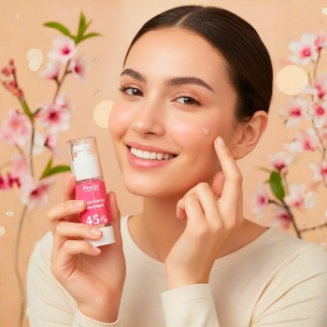
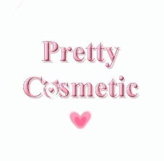
- Main Designs
Poster
KPIs (Key Performance Indicators) :
- Views
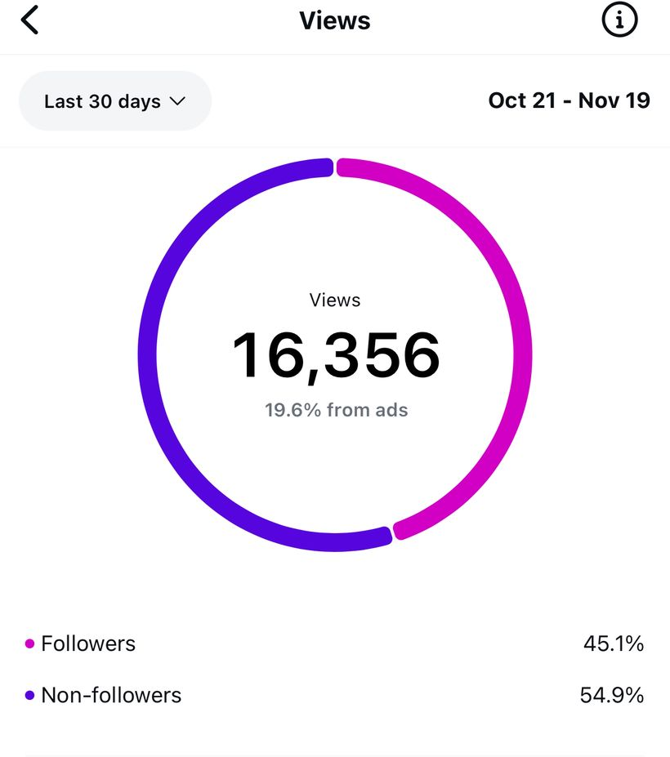
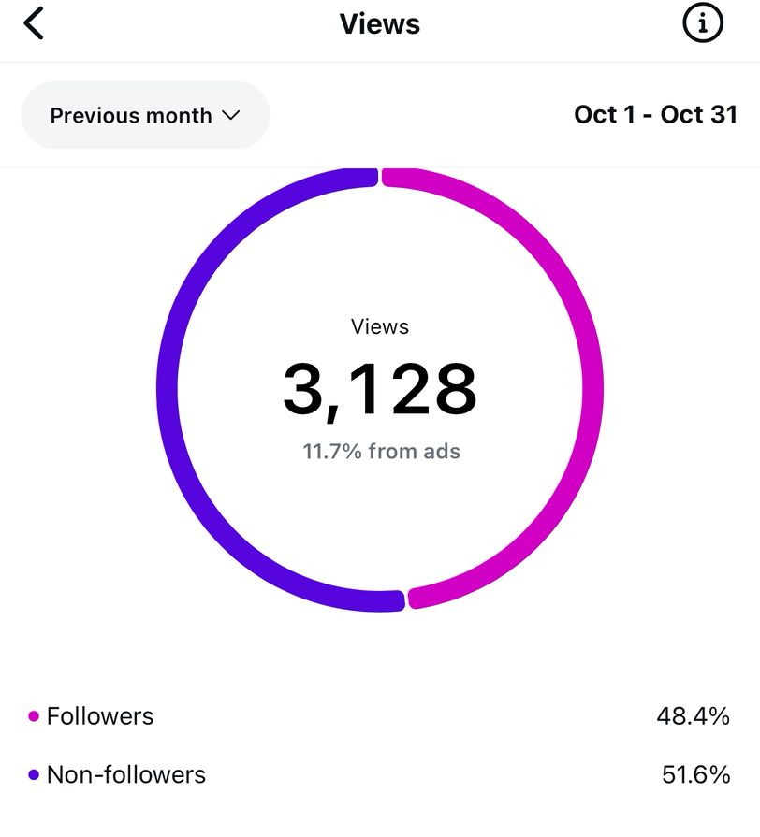

Before After
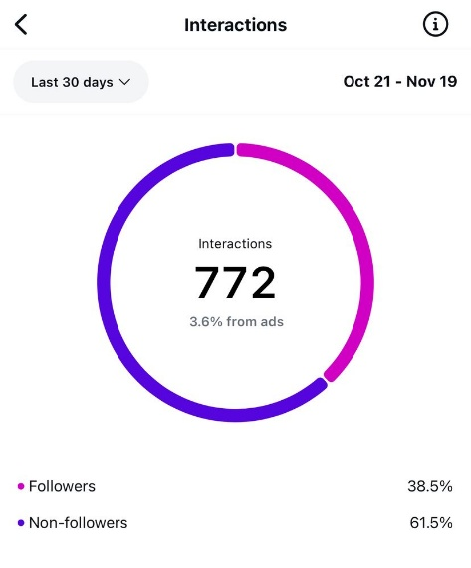
- Interactions
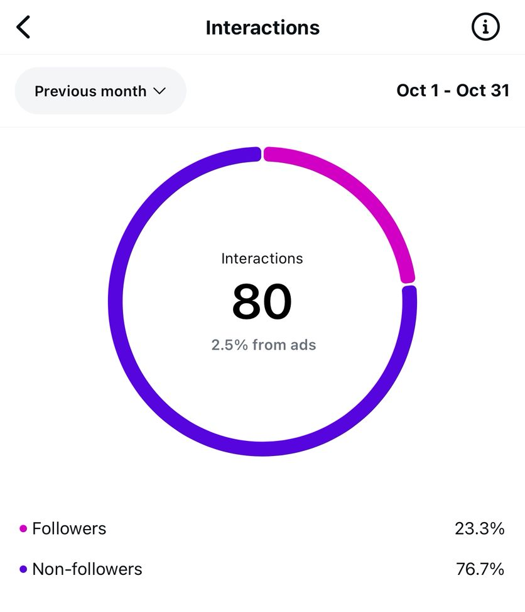

Before After

Instructor
Youssef Ayman

Project Files
You can find the full project files here:
http://drive.google.com/drive/folders/1nMGVqDB9MRJIexrJdp2UV65opjoCeMyg

License
This project is licensed for team 2 DEPI

